For SVR the objective function is shown in below.

Here we are minimizing 1/margin that means maximizing margin difference, so what we are trying to do, is creating to boundary planes, and one plane b/w them, such that most of the points comes between that boundary plane.

Here constraints are y_i – (w_T . x_i +b) <= epsilon, so here we are saying that diff b/w actual output and predicted output should be less than epsilon, or error should be less than epsilon.

Here epsilon is the hyperparameter.

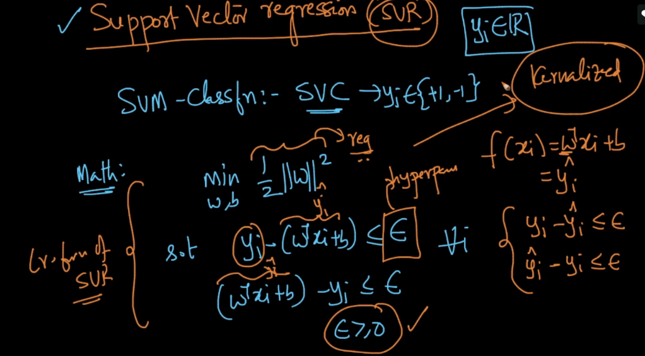

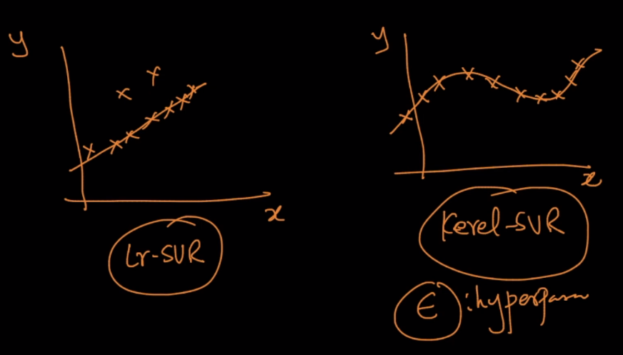

If we decrease epsilon, that means we are allowing to have fewer error as much as possible on training data which leads to overfit.

If we increase epsilon, that means we are allowing to have more errors in training dataset which leads to underfit.

